Snowflake Coding Assessment
A retail company receives daily order files from its sales application.
The source application uploads CSV files into an Azure Storage Account.
Snowflake should automatically load the new files whenever they arrive in Azure Storage.
The company wants:
1. A separate Snowflake warehouse for loading data
2. A separate user and role for data engineering
3. Data ingestion from Azure Storage Account
4. Initial load from CSV file
5. Automatic incremental loading when new CSV files are uploaded
6. Avoid duplicate records in the final table
Important Concept for Students
Snowflake does not automatically detect new rows added inside the same old file.
Best practice is:
Do not edit the already uploaded CSV file.
Instead, upload a new CSV file for every new batch.
Example:
retail_orders_initial.csv
retail_orders_incremental_20260508.csv
retail_orders_incremental_20260509.csv
retail_orders_incremental_20260510.csv
Snowpipe detects and loads new files, not newly edited rows inside the same file.
A: Snowflake Setup
- Create a database named RETAIL_DB.
- Create a schema named RETAIL_DB.ORDERS_DEMO.
- Create a warehouse named RETAIL_LOAD_WH.
- Create a role named RETAIL_DATA_ENGINEER_ROLE.
- Create a user named RETAIL_ENGINEER_USER.
- Grant required permissions to the role and user.
Ans:
create or replace database retail_db;
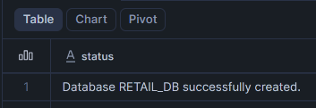
create or replace schema retail_db.orders_demo;
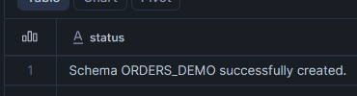
create or replace warehouse retail_load_wh
with
warehouse_size='XSMALL'
auto_suspend=60
auto_resume=True;
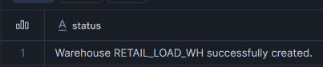
create or replace role retail_data_engineer_role;
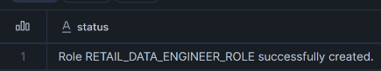
create or replace user retail_engineer_user
password="Retail@12345"
login_name="Retail Engineer User"
first_name="Retail Engineer"
last_name="User"
email="Retail@example.com"
must_change_password=FALSE
Default_warehouse=retail_load_wh;
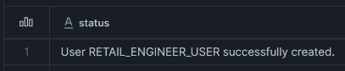
use role securityadmin;

grant role retail_data_engineer_role to user retail_engineer_user;

use role accountadmin;

grant usage on warehouse retail_load_wh to role retail_data_engineer_role;
grant usage on database retail_db to role retail_data_engineer_role;
grant usage on schema retail_db.orders_demo to role retail_data_engineer_role;
Outputs:
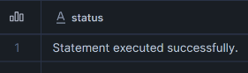
Part B: Azure Storage Setup
- Create an Azure Storage Account.
- Create a container named retail-data.
- Inside the container, create this folder path:
raw/orders/
- Upload the initial CSV file:
retail_orders_initial.csv
Outputs:
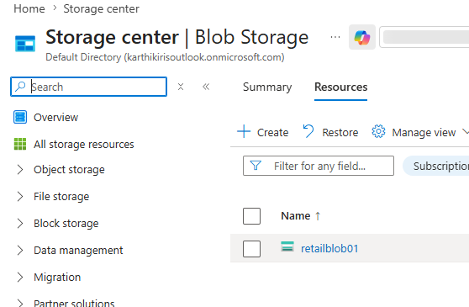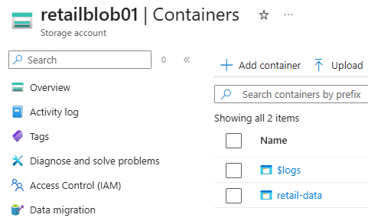
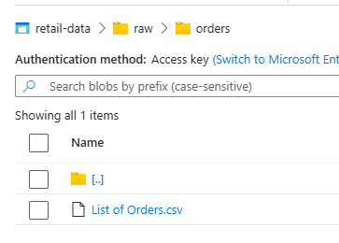
Part C: Snowflake External Stage
- Create a file format for CSV.
- Create an Azure storage integration or external stage.
- Create an external stage pointing to:
azure://<storage_account>.blob.core.windows.net/retail-data/raw/orders/
- List files from the stage.
Ans:
create or replace file format retail_db.orders_demo.csv_format
type=csv
field_delimiter=','
skip_header=1
date_format="dd-mm-yyyy";
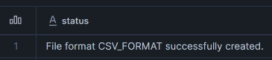
create or replace stage retail_db.orders_demo.retail_stage
url="azure://retailblob01.blob.core.windows.net/retail-data/raw/orders/"
credentials=(
azure_sas_token='sv=2026-02-06&ss=bfqt&srt=sco&sp=rwdlacupiytfx&se=2026-05-21T18:46:58Z&st=2026-05-21T10:31:58Z&spr=https,http&sig=WFWmUzoGdS%2BEbXbwJ2kblSS2XjB9RU9r6TtPpaf7uxk%3D'
)
file_format=retail_db.orders_demo.csv_format;
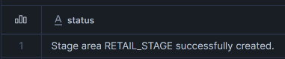
list @retail_db.orders_demo.retail_stage;
Part D: Initial Data Load
- Create a raw landing table named ORDERS_RAW.
- Create a final table named ORDERS_FINAL.
- Load the initial file into ORDERS_RAW.
- Insert data into ORDERS_FINAL.
Ans:
create or replace table retail_db.orders_demo.orders_raw(
order_id string,
order_date date,
customer_name string,
state string,
city string
);
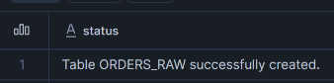
create or replace table retail_db.orders_demo.orders_final(
order_id string,
order_date date,
customer_name string,
state string,
city string
);
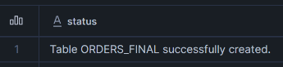
copy into retail_db.orders_demo.orders_raw
from (select
$1,
TO_DATE($2,'DD-MM-YYYY'),
$3,
$4,
$5
from @retail_db.orders_demo.retail_stage);
insert into retail_db.orders_demo.orders_final
select * from retail_db.orders_demo.orders_raw;
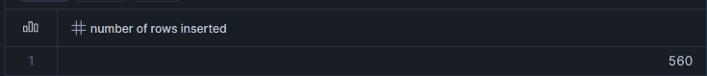
Part E: Incremental Loading
- Create a Snowpipe object to load new files automatically into ORDERS_RAW.
- Create a stream on ORDERS_RAW.
- Create a task to merge new rows from the stream into ORDERS_FINAL.
- Upload another CSV file into Azure Storage.
- Verify that new rows are automatically loaded into Snowflake.
Ans:
create or replace pipe retail_db.orders_demo.snowpipe
as
copy into retail_db.orders_demo.orders_raw
from (select
$1,
TO_DATE($2,'DD-MM-YYYY'),
$3,
$4,
$5
from @retail_db.orders_demo.retail_stage);
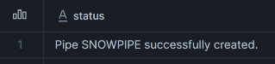
alter pipe retail_db.orders_demo.snowpipe refresh;
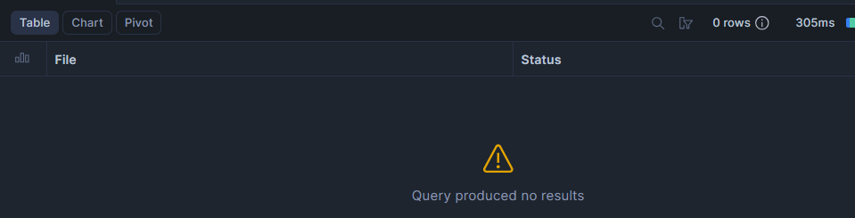
create or replace stream retail_db.orders_demo.orders_stream
on table retail_db.orders_demo.orders_raw;
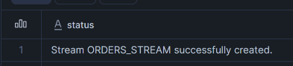
create or replace task retail_db.orders_demo.orders_task
warehouse=retail_load_wh
when system$stream_has_data('retail_db.orders_demo.orders_stream')
as

merge into retail_db.orders_demo.orders_final T

using(
select * from retail_db.orders_demo.orders_stream
where metadata$action='INSERT'
) S

on T.order_id=S.order_id

when not matched then
insert (
order_id,
order_date,
customer_name,
state,
city
)
values (
S.order_id,
S.order_date,
S.customer_name,
S.state,
S.city
);
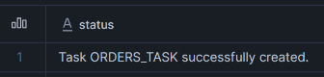
alter task retail_db.orders_demo.orders_task resume;

#Now upload the incremental csv file into the blob storage account and refresh the pipe to manually upload the csv file into tables orders_raw
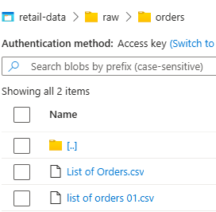

alter pipe retail_db.orders_demo.snowpipe refresh;

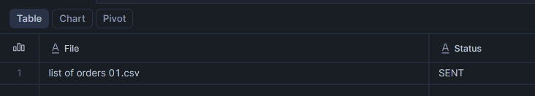
select * from retail_db.orders_demo.orders_raw;
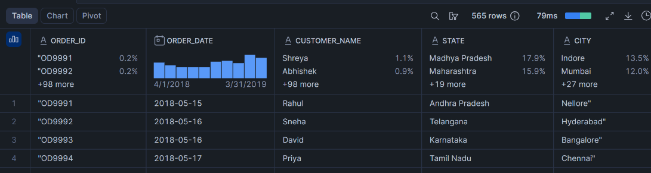
select * from retail_db.orders_demo.orders_final;
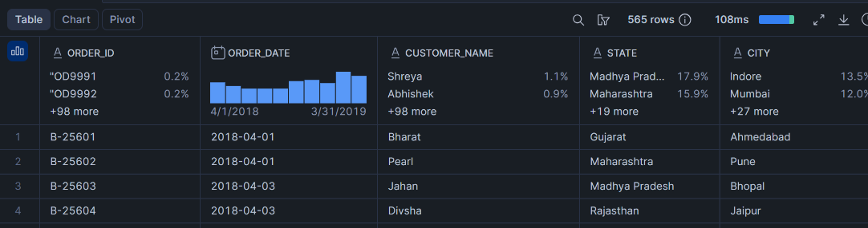
select * from retail_db.orders_demo.orders_stream;
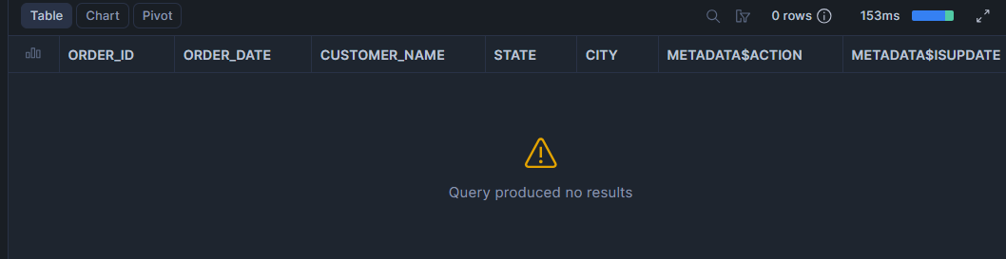
As you can see in the initial load there are 560 rows and through the incremental load there are 5 new rows automatically loaded into the orders_raw and orders_final tables through snowpipe, task and consumption of stream.

